OWNERS MANUAL
Installation & Operating Instructions
For Homefires Gas Coal And Gas Log Fires Using Hand Held Ignition for Natural Gas

Please read these instructions carefully before you begin to install this gas coal/log set.
NOTE: Installer should leave these instructions with the customer for future reference.

This fireplace gas coal/log set is for use with NATURAL GAS ONLY. Installation and all repairs must be performed by an individual who is experienced and certified in the installation, repairs, and servicing of vented gas coal/log sets. The installer should also be covered by their own general liability policy.

W A R N I N G
If the information in this manual is not followed exactly, a fire or explosion may result causing property damage, personal injury or loss of life.
FOR INSTALLATION IN A VENTED FIREPLACE ONLY
THE FIREPLACE CHIMNEY MUST HAVE A PERMANENT VENT OPENING TO ATMOSPHERE.
KEEP DAMPER WIDE OPEN WHEN IN USE.
Do not burn wood or other material in any fireplace fitted with a gas coal/log set.
A fireguard should be used with this appliance for the protection of children and the elderly.

F O R Y O U R S A F E T Y
DO NOT STORE OR USE GASOLINE OR OTHER FLAMMABLE LIQUIDS IN THE VICINITY OF THIS OR ANY OTHER APPLIANCE.
Young children are not allowed to operate this unit, and should be supervised when they are in the same room with the appliance.
Do not use this appliance or any part that has been under water.

F O R Y O U R S A F E T Y
WHAT TO DO IF YOU SMELL GAS:
- Open windows
- Do not try to light any appliances
- Do not touch any electrical switch; do not use any phone in your building
- Immediately call your gas supplier from a neighbor’s phone, and follow their instructions.
- If you cannot reach the gas supplier, call the fire department

~ ATTENTION: HOMEOWNER ~

THIS APPLIANCE MAY ONLY BE INSTALLED IN A SOLID-FUEL BURNING FIREPLACE OR IN A MANUFACTURED VENTED FIREPLACE AS SPECIFIED BY THE APPLIANCE’S INSTALLATION INSTRUCTIONS.

THIS APPLIANCE IS A GAS-FIRED APPLIANCE WHICH REQUIRES FRESH AIR (OXYGEN) FOR PROPER COMBUSTION AND VENTILATION. FIREPLACE BLOWERS ARE NOT PERMITTED FOR USE IN CONJUNCTION WITH THIS APPLIANCE.

DUE TO THE NATURE OF THE PRODUCT, SOME CHANGES IN THE APPEARANCE OF YOUR GRATE WILL DEVELOP OVER TIME. EVERY FIRE BURNS DIFFERENTLY SO IT IS IMPOSSIBLE TO SAY EXACTLY HOW YOUR FIREGRATE WILL LOOK IN TEN YEARS. WE BELIEVE THAT OUR FIRES ONLY GET BETTER WITH AGE AND LOOK MORE REALISTIC THE MORE THEY ARE USED. THE IMPINGEMENT OF THE FLAMES AT ABOUT 600C ON THE BLACK SURFACE OF THE BACK PLATES MAY EVENTUALLY TAKE THE BLACK COLORING OFF AND LEAVE THE NATURAL GRAY COLOR OF THE IRON OR STEEL. THIS IS PERFECTLY NORMAL AND CANNOT BE PREVENTED. THE FRONT STEEL BARS, AGAIN AFTER FLAME IMPINGMENT, MAY DISCOLOR OVER TIME DUE TO INTENSE HEAT. IF YOU PREFER TO KEEP THE SHINEY AND NEW LOOK YOU MAY PAINT THE BACK PLATE WITH A BLACK STOVE PAINT OR POLISH THE BARS WITH STEEL POLISH EVERY YEAR OR SO. IN EUROPE, NO ONE EVER POLISHED THEIR GRATE. IN FACT, PEOPLE REGULARLY WANT TO BUY USED OR DISPLAY GRATES THAT LOOK MORE LIKE ANTIQUES. THE BRASS DOES HAVE A HEAT RESISTANT LAQUER ON IT AND SHOULD NOT BE CLEANED WITH ANY TYPE OF CLEANING AGENT. THERE REALLY IS NO MAINTENANCE IN KEEPING UP YOUR FIREGRATE, THEY WILL LAST FOR HUNDEREDS OF YEARS WITHOUT HELP!!

BEFORE INSTALLING THIS APPLIANCE IN A PREVIOUSLY USED FIREPLACE, THOUROUGHLY CLEAN THE INTERIOR OF THE FIREPLACE (INCLUDING ANY SMOKE SHELF, DAMPER, DAMPER FRAME, AND CHIMNEY) OF SOOT, CREOSOTE, ASHES OR ANY OTHER SUBSTANCE WHICH COULD BE TRANSPORTED BY WATER VAPOR OR CIRCULATED BY AIR FLOW INTO THE SPACE SERVED BY THIS APPLIANCE. NOTE: CLEANING OF A SOLID FUEL BURNING FIREPLACE IS BEST DONE BY A PORESSIONAL CHIMNEY SWEEP.

THE COALS ARE MADE FROM A CERAMIC FIBRE WHICH IS BOUND TOGETHER WITH A STARCH AND SODIUM SILICATE. THE STARCH BURNS OUT AND DOES HAVE A SLIGHT ODOR AS IT CURES WHEN FIRST USED (2-3 HOURS). THE SMELL SHOULD NOT CONTINUE AS ALL ODOR AND CUMBUSTION BY-PRODUCTS SHOULD FOLLOW THE DRAFT UP-AND-OUT OF YOUR HOME.

NOTE: DO NOT LET THE COALS OF ANY PART OF THE FIREPLACE GET WET. THIS WILL CAUSE RUST TO DEVELOP ON THE FIREBASKET AND COULD CAUSE THE COALS TO GIVE OFF A BAD ODOR.

KEEP THIS APPLIANCE AND THE FIREPLACE IN WHICH IT IS INSTALLED CLEAN AS SPECIFIED BY THE APPLIANCE’S MAINTENANCE INSTURCTIONS.

GENERAL INFORMATION
- This gas coal/log set is only to be installed and used in a fully vented fireplace with a completely functional damper and chimney that is free of any obstructions. The fireplace must be constructed of non-combustible materials and approved to burn wood.

- To operate this gas coal/log set, the flue damper must be fully opened and locked.

- To be installed in a fireplace with a minimum height of 20”, a minimum depth of 12” and a minimum width of 3 inches greater than the max-imum width of the firegrate being installed. The flue size and height must be related to the size of the fireplace opening. For example, a big fire-place needs a tall wide flue. This gas coal/log set will normally require a chimney flue of at least 8 inches in diameter to clear its fumes. If in doubt consult your supplier. Do not use if fumes from the burner emerge into the room when the damper is fully open. This indicates that there is not adequate draft. Do not use until the problem is corrected.

- If the fireplace has glass doors, operate the set with the doors fully opened. A fireplace screen, with an opening for introduction of combustion air, should be used when operating this appliance.

- The nominal inlet gas pressure for this appliance is 7” water column for natural gas.

- This gas appliance and its individual shutoff valve must be disconnected from the gas supply piping system during any pressure testing at pressures in excess of ½ PSIG.

- Do not move or jostle the grate once it has been connected to the gas line.

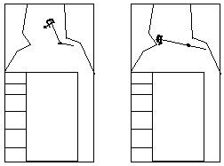
- The national Health and Safety Board recommend 1CO (carbon monoxide) detector for each floor.

- The installation of the appliance and the provisions for combustion and ventilation air must conform with NFPA 54 unless otherwise noted in local building and safety codes.

- The minimum permanent free fireplace opening required is 70 square inches.
FIREPLACE PREPARATION
- Remove all ash and debris from the inside of the fireplace.

- Prior to connecting the gas coal/log set, make sure the gas supply is completely shut off.

- Prior to installation, a smoke test should be performed using a smoke pellet. The pellet is ignited at the base of the flue in the fireplace opening. All the smoke created must be emitted at the termination of the flue without spillage from the fireplace opening or without leakage from the flue in other parts of the building.

If spillage is taking place then either:
- The flue is partially blocked
- The fireplace opening is too great for the height of the flue
- The flue diameter is too narrow for the size of the fireplace opening

- A damper clamp must be fixed to the damper blade or the damper must be completely removed before installation of this appliance.

A damper clamp is provided as a means to prevent full and/or accidental closure of the fireplace damper when installed as illustrated.
To install the clamp:
- Open the fireplace damper
- Place the damper clamp over the damper blade.
- Tighten the set screw of the clamp so that it is permanently affixed to the damper blade.
- Should the clamp not fit, install a permanent damper stop or provide some other means of preventing full and/or accidental closure of the damper.
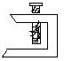

INSTALLATION INSTRUCTIONS

Firegrate & Burner Pan Placement

- The firegrate should sit in the center back of the fireplace.

- The burner sits in the bottom of the firegrate with the control knob facing the Side (see drawing) and the receiver facing the Front.

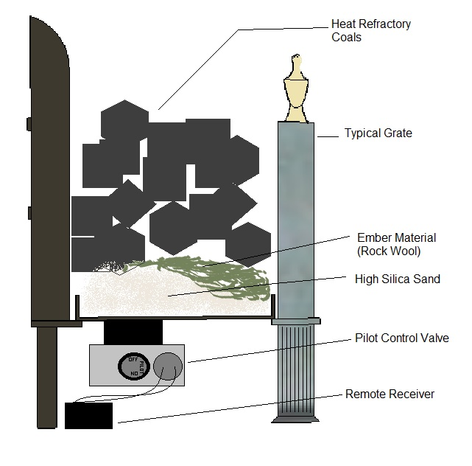
- Due to the hand-crafted nature of these firebaskets, differences in dimensions sometimes occur. In these cases, two burner clips are provided to secure/center the burner inside of the grate.
- Place the burner tray into the bottom of the firegrate
- Before pouring in the silica sand; place the burner clip with the slotted side down so that the side wall of the burner tray fits into the slot. Use the screw portion of the piece to increase/decrease tension as necessary.
- In some cases, the burner will be affixed with screws and the clips are not needed.

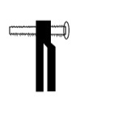
Burner Clip:

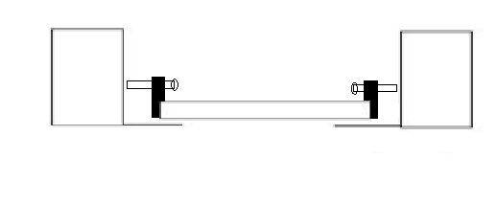

Connecting Gas Supply to Burner Pan

The 3/8” gas tubing will enter from the back of the fireplace and should be fitted inconspicuously at the back of the hearth. Purge the gas supply pipe to remove air and debris BEFORE connection of appliance. Run the pipe to and connect/seal it to the inlet side of the flame failure valve beneath the firegrate. Visible gas piping should be painted black.

Note: We recommend PTFE Teflon tape NOT Pipe dope for sealing

Note: For pipe sizing concerns, see pipe sizing chart. Ultimately, you are responsible for installing this appliance in compliance with local building and safety codes.

Warning: Flexible pipe should NOT be used. Hard pipe makes less noise and using it will help solidify the whole burner system.

Connecting Remote & Receiver

Read the enclosed instructions for remote control & receiver entirely. These will explain all features and operation procedures of the system.
The receiver should be placed on the floor of the fireplace, generally towards the rear of the firebox. It is possible to place the receiver behind the back plate because the remote uses radio waves. This is often the best placement.
Follow directions to learn the transmitter to receiver as explained in the remote’s instructions under “Learning Transmitter To Receiver”

Sand, Ember, and Coal Placement

- Fill the burner to the top edge with the high silica sand supplied. Overfill rather than underfill.

- Break the green ember material into smaller pieces and place it evenly over the sand bed, particularly piling toward the center and along the front edge. If Embaglow embers are enclosed follow instructions on packaging for placement.

- If you have a log fire, place the logs in any pleasing arrangement, but stack them loosely with air spaces between the logs. For a coal fire, stack the coals as loosely as possible with slightly tighter configuration along the backplate.

Warning:

Improper installation may cause Carbon Monoxide Poisoning. Carbon Monoxide, which is an odorless and colorless gas, is a by-product of combustion. Caution must be taken to insure the fireplace is properly vented when set is in use. To avoid having potentially dangerous fumes enter the living area, be sure the chimney is drawing properly.

OPERATING INSTRUCTIONS

Lighting Your Gas Coal/Log Set (remote valve only)

- Turn Pilot Control knob counterclockwise toward the PILOT position until reaching a stop, press in and hold for 10 seconds (only pilot gas flows).

- While holding knob down, use a match to light the pilot flame. Continue to hold down for 20 seconds after pilot flame has been lit. You may then release the knob; if the pilot does not light or stay lit, steps one and two can be repeated immediately.

- These controls are factory preset and will not normally require additional adjustment of the pilot flame. But if field adjustment of the pilot is required, turn the adjusting screw clockwise to reduce flame or counterclockwise to increase flame. The adjustment screw is centered on the bottom of the valve, facing the same direction as the pilot control knob. It is a small flathead brass screw, inset into a surround of metal. If pilot makes excessive noise, the flame may need to be adjusted down.

- Upon lighting of pilot flame, turn knob fully counterclockwise to the ON position. Pilot gas flows and main gas flows in accordance to the flame setting that the motorized control has been set on.

NOTE: When operating this appliance by remote control it is not required to turn the pilot burner off after each and every time that the appliance is used. The operation of the OFF button shuts off the gas supply to the main burner.

NOTE: The Pilot Control knob must be turned to the ON position for main burner flames to be activated by motor or remote.

SHUT OFF PROCEDURE

- Turn Pilot Control knob clockwise until reaching a stop. In this position only pilot gas flows, and main burner is not functional.

- To shut off the valve completely, continue turning clockwise from the pilot position to the OFF position. The safety interlock prevents re-ignition of pilot flame until the thermocouple has cooled down sufficiently.

- Switching off the remote is not necessary.

Spillage Test:

Turn the fire on. After 20 seconds, take a standard lighter and move it slowly along the top of the fireplace opening just inside the fireplace. If the flame is drawn into the fireplace then draft is correct. If the flame is coming towards the room the fireplace is spilling. You can then test again with a piece of burning paper; the smoke should be drawn into the fireplace and up the chimney. If smoke can be seen coming into the room the fireplace is spilling. Dis-connect the appliance and correct the flue system.

MAINTENANCE

Very little if any maintenance is required. The carbon deposits resulting from use is natural and adds to the realistic appearance of the set. If carbon becomes excessive it can be lightly brushed away. It is most important that you have your fire serviced once a year. This is to insure that combustion remains correct and that your flue remains clear and unobstructed so that no dangerous fumes can spill into your room. Batteries may require seasonal replacement.

GUARANTEE/WARRANTY

These logs and coals are guaranteed against breakage in normal use for their replacement for a period of 4 years from the date of purchase. All other components are guaranteed against defects in material and workmanship for a period of 2 years from date of purchase. This excludes variations in color which occur naturally from heat impingement. Claims under this guarantee should be accompanied by the original purchase invoice. This warranty does not apply in the case of improper installation, neglect, accident, misuse or as a result of modifications of the original product. All costs for removal and reinstallation are the expressed responsibility of the purchaser. Failure to follow all instructions in the Owner’s Manual will also void this warranty. Real Flame and AQR Incorporated will not be liable for incidental or consequential damages. If this item fails due to defect in material or craftsmanship, we will replace or repair, at our option, free of charge. To order parts or obtain warranty service, call or write to AQR Inc. We do all in our power to help our customer at every turn. If you ever need help or have questions not answered in these instructions please feel free to call.

AQR
INCORPORATED

AQR Inc. dba Homefires
2644 Shenandoah Avenue
Charlotte, NC 28205

Phone: 800-749-4049
Fax: 704-376-0268

Web: www.homefiresusa.com
Email: alex@homefiresusa.com

